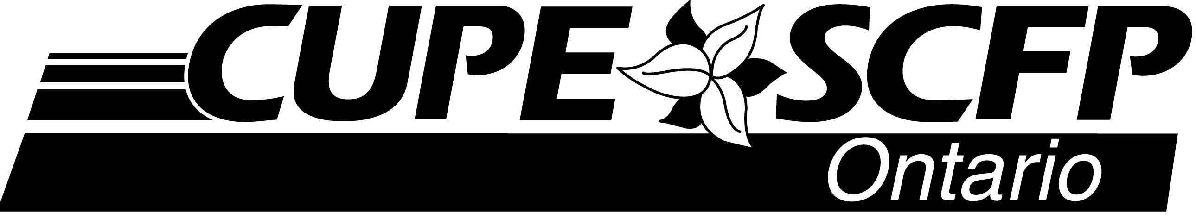
80 Commerce Valley Drive East, Suite 1
Markham, ON L3T 0B2
Phone: 905-739-9739 • Fax: 905-739-9740
Web: cupe.on.ca E-mail: info@cupe.on.ca

FOR IMMEDIATE RELEASE MEDIA RELEASE September 6, 2019
(COMMUNITY HERE) takes action for Communities, not Cuts
(COMMUNITY), ON
Local activists and their community allies took action today in support of their community and against the cuts being imposed by the Ford Conservatives.
“We are here today because we believe in Communities, not Cuts,” said (NAME AND TITLE HERE).
(BRIEF DESCRIPTION OF EVENT GOES HERE – include community or coalition partners involved)
Communities, not Cuts is a province wide campaign conducted by CUPE Ontario that supports and encourages local activists who are pushing back against the Ford Conservative government’s cutbacks happening in their community
“The Ford Conservatives’ cuts are harming communities across this province, including right here in (COMMUNITY), said Fred Hahn, President of CUPE Ontario. (QUOTE ABOUT THE IMPORTANCE OF THE WORK/SERVICES BEING CUT).
Since taking office last year, the Ford Conservatives have announced billions of dollars in cuts to the funding for vital public services to pay for tax cuts to the wealthy. In (COMMUNITY), that’s meant (DESCRIPTION OF THE CUTBACKS TAKING PLACE IN COMMUNITY) - include as much detail as possible – services lost, jobs lost, timetable, etc.). Hahn said today’s event is proof Ontarians are opposed to tax cuts for the wealthy and public service cuts for the rest of us.
“That’s why we are proud to support the work happening here in (COMMUNITY) to bring people together to support their community, to fight back against the Ford Conservative’s cuts, and protect the vital public services that people depend on,” he added.

-30-
For more information, please contact: (LOCAL PERSON NAME AND CONTACT #)
Marla Di Candia, CUPE Ontario Communications contact: 416-523-3124

dd/cope491

